**CHAPTER 1**

**ABOUT COGNIZANT**

**1.1 INTRODUCTION**

COGNIZANT is an American [multi-national corporation](mhtml:file://C:\Users\Nivetha\Downloads\SHAREit\ONEPLUS%20A6000\file\Cognizant%20-%20Wikipedia.mhtml!https://en.m.wikipedia.org/wiki/Multinational_corporation) that provides IT services, including digital, technology, consulting, and operations services. It is headquartered in [Teaneck](mhtml:file://C:\Users\Nivetha\Downloads\SHAREit\ONEPLUS%20A6000\file\Cognizant%20-%20Wikipedia.mhtml!https://en.m.wikipedia.org/wiki/Teaneck,_New_Jersey), [New Jersey](mhtml:file://C:\Users\Nivetha\Downloads\SHAREit\ONEPLUS%20A6000\file\Cognizant%20-%20Wikipedia.mhtml!https://en.m.wikipedia.org/wiki/New_Jersey), United States. Cognizant is included in the [NASDAQ-100](mhtml:file://C:\Users\Nivetha\Downloads\SHAREit\ONEPLUS%20A6000\file\Cognizant%20-%20Wikipedia.mhtml!https://en.m.wikipedia.org/wiki/NASDAQ-100) and the [S&P 500](mhtml:file://C:\Users\Nivetha\Downloads\SHAREit\ONEPLUS%20A6000\file\Cognizant%20-%20Wikipedia.mhtml!https://en.m.wikipedia.org/wiki/S%26P_500) indices. It is also one of the fastest growing Fortune 500 companies. It was founded as an in-house technology unit of [Dun & Bradstreet](mhtml:file://C:\Users\Nivetha\Downloads\SHAREit\ONEPLUS%20A6000\file\Cognizant%20-%20Wikipedia.mhtml!https://en.m.wikipedia.org/wiki/Dun_%26_Bradstreet) in 1994, and started serving external clients in 1996.

|  |  |
| --- | --- |
| [**Type**](mhtml:file://C:\Users\Nivetha\Downloads\SHAREit\ONEPLUS%20A6000\file\Cognizant%20-%20Wikipedia.mhtml!https://en.m.wikipedia.org/wiki/List_of_legal_entity_types_by_country) | [**Public**](mhtml:file://C:\Users\Nivetha\Downloads\SHAREit\ONEPLUS%20A6000\file\Cognizant%20-%20Wikipedia.mhtml!https://en.m.wikipedia.org/wiki/Public_company) |
| **Industry** | [IT services](mhtml:file://C:\Users\Nivetha\Downloads\SHAREit\ONEPLUS%20A6000\file\Cognizant%20-%20Wikipedia.mhtml!https://en.m.wikipedia.org/wiki/IT_service_management), [IT consulting](mhtml:file://C:\Users\Nivetha\Downloads\SHAREit\ONEPLUS%20A6000\file\Cognizant%20-%20Wikipedia.mhtml!https://en.m.wikipedia.org/wiki/Information_technology_consulting) |
| **Predecessor** | [Dun & Bradstreet](mhtml:file://C:\Users\Nivetha\Downloads\SHAREit\ONEPLUS%20A6000\file\Cognizant%20-%20Wikipedia.mhtml!https://en.m.wikipedia.org/wiki/Dun_%26_Bradstreet) |
| **Founded** | January 26, 1994; 25 years ago (1994-01-26) |
| **Founders** | [Kumar Mahadeva](mhtml:file://C:\Users\Nivetha\Downloads\SHAREit\ONEPLUS%20A6000\file\Cognizant%20-%20Wikipedia.mhtml!https://en.m.wikipedia.org/wiki/Kumar_Mahadeva) |
| **Headquarters** | [Teaneck, New Jersey](mhtml:file://C:\Users\Nivetha\Downloads\SHAREit\ONEPLUS%20A6000\file\Cognizant%20-%20Wikipedia.mhtml!https://en.m.wikipedia.org/wiki/Teaneck,_New_Jersey)  U.S. |
| **Area served** | Worldwide |
| **Key people(CEO)** | [Francisco D'Souza](mhtml:file://C:\Users\Nivetha\Downloads\SHAREit\ONEPLUS%20A6000\file\Cognizant%20-%20Wikipedia.mhtml!https://en.m.wikipedia.org/wiki/Francisco_D%27Souza) (CEO) |
| **Services** | [IT Services](mhtml:file://C:\Users\Nivetha\Downloads\SHAREit\ONEPLUS%20A6000\file\Cognizant%20-%20Wikipedia.mhtml!https://en.m.wikipedia.org/wiki/Information_Technology), [business consulting](mhtml:file://C:\Users\Nivetha\Downloads\SHAREit\ONEPLUS%20A6000\file\Cognizant%20-%20Wikipedia.mhtml!https://en.m.wikipedia.org/wiki/Business_consulting) and [outsourcing](mhtml:file://C:\Users\Nivetha\Downloads\SHAREit\ONEPLUS%20A6000\file\Cognizant%20-%20Wikipedia.mhtml!https://en.m.wikipedia.org/wiki/Outsourcing) services |
| **Revenue** | [US$](mhtml:file://C:\Users\Nivetha\Downloads\SHAREit\ONEPLUS%20A6000\file\Cognizant%20-%20Wikipedia.mhtml!https://en.m.wikipedia.org/wiki/United_States_dollar)16.12 billion (2018) |
| [**Operating income**](mhtml:file://C:\Users\Nivetha\Downloads\SHAREit\ONEPLUS%20A6000\file\Cognizant%20-%20Wikipedia.mhtml!https://en.m.wikipedia.org/wiki/Earnings_before_interest_and_taxes) | US$2.80 billion (2018) |
| [**Net income**](mhtml:file://C:\Users\Nivetha\Downloads\SHAREit\ONEPLUS%20A6000\file\Cognizant%20-%20Wikipedia.mhtml!https://en.m.wikipedia.org/wiki/Net_income) | US$2.10 billion (2018) |
| [**Total assets**](mhtml:file://C:\Users\Nivetha\Downloads\SHAREit\ONEPLUS%20A6000\file\Cognizant%20-%20Wikipedia.mhtml!https://en.m.wikipedia.org/wiki/Asset) | US$15.91 billion (2018) |
| **Number of employees** | 281,600 (2018 Q4) |

**1.2. SERVICES**

Cognizant provides information technology, information security, consulting, ITO and BPO services. These include business & technology consulting, [systems integration](mhtml:file://C:\Users\Nivetha\Downloads\SHAREit\ONEPLUS%20A6000\file\Cognizant%20-%20Wikipedia.mhtml!https://en.m.wikipedia.org/wiki/Systems_integration), application development & maintenance, IT infrastructure services, analytics, [business intelligence](mhtml:file://C:\Users\Nivetha\Downloads\SHAREit\ONEPLUS%20A6000\file\Cognizant%20-%20Wikipedia.mhtml!https://en.m.wikipedia.org/wiki/Business_intelligence), [data warehousing](mhtml:file://C:\Users\Nivetha\Downloads\SHAREit\ONEPLUS%20A6000\file\Cognizant%20-%20Wikipedia.mhtml!https://en.m.wikipedia.org/wiki/Data_warehousing), [customer relationship management](mhtml:file://C:\Users\Nivetha\Downloads\SHAREit\ONEPLUS%20A6000\file\Cognizant%20-%20Wikipedia.mhtml!https://en.m.wikipedia.org/wiki/Customer_relationship_management), [supply chain management](mhtml:file://C:\Users\Nivetha\Downloads\SHAREit\ONEPLUS%20A6000\file\Cognizant%20-%20Wikipedia.mhtml!https://en.m.wikipedia.org/wiki/Supply_chain_management), engineering & manufacturing solutions, [enterprise resource planning](mhtml:file://C:\Users\Nivetha\Downloads\SHAREit\ONEPLUS%20A6000\file\Cognizant%20-%20Wikipedia.mhtml!https://en.m.wikipedia.org/wiki/Enterprise_resource_planning), [research and development](mhtml:file://C:\Users\Nivetha\Downloads\SHAREit\ONEPLUS%20A6000\file\Cognizant%20-%20Wikipedia.mhtml!https://en.m.wikipedia.org/wiki/Research_and_development) outsourcing, and [testing](mhtml:file://C:\Users\Nivetha\Downloads\SHAREit\ONEPLUS%20A6000\file\Cognizant%20-%20Wikipedia.mhtml!https://en.m.wikipedia.org/wiki/Software_testing) solutions.

Cognizant has three key practice areas that span its business Digital Business, Digital Operations, and Digital Systems & Technology.

**1.3. BUSINESS MODEL**

Cognizant's original corporate headquarters in [Chennai](mhtml:file://C:\Users\Nivetha\Downloads\SHAREit\ONEPLUS%20A6000\file\Cognizant%20-%20Wikipedia.mhtml!https://en.m.wikipedia.org/wiki/Chennai), now an offshore delivery centre. In its early years, Cognizant gained business from a number of American and European companies with the help of the Dun & Bradstreet brand. The company's senior executives envisaged the firm as a provider of high-end customer services on-par with the six contemporary major [system integrators](mhtml:file://C:\Users\Nivetha\Downloads\SHAREit\ONEPLUS%20A6000\file\Cognizant%20-%20Wikipedia.mhtml!https://en.m.wikipedia.org/wiki/System_integrator) but at lower prices. Cognizant was ranked at 195 in Fortune top 200 lists of 2018.

Cognizant's excellence and shift to digital marketing, digital platforms interests and expertise in nearly all the leading database, digital marketing and emerging technologies has fetched it an eminent position across the globe.

**1.4. OPERATIONS**

**1.4.1. Region**

The company has more than 281,600 employees globally, of which over 150,000 are in India across 10 locations with a plurality in [Chennai](mhtml:file://C:\Users\Nivetha\Downloads\SHAREit\ONEPLUS%20A6000\file\Cognizant%20-%20Wikipedia.mhtml!https://en.m.wikipedia.org/wiki/Chennai). The other centres of the company are in [Bangalore](mhtml:file://C:\Users\Nivetha\Downloads\SHAREit\ONEPLUS%20A6000\file\Cognizant%20-%20Wikipedia.mhtml!https://en.m.wikipedia.org/wiki/Bangalore), [Coimbatore](mhtml:file://C:\Users\Nivetha\Downloads\SHAREit\ONEPLUS%20A6000\file\Cognizant%20-%20Wikipedia.mhtml!https://en.m.wikipedia.org/wiki/Coimbatore), [Gurgaon](mhtml:file://C:\Users\Nivetha\Downloads\SHAREit\ONEPLUS%20A6000\file\Cognizant%20-%20Wikipedia.mhtml!https://en.m.wikipedia.org/wiki/Gurgaon), [Noida](mhtml:file://C:\Users\Nivetha\Downloads\SHAREit\ONEPLUS%20A6000\file\Cognizant%20-%20Wikipedia.mhtml!https://en.m.wikipedia.org/wiki/Noida), [Hyderabad](mhtml:file://C:\Users\Nivetha\Downloads\SHAREit\ONEPLUS%20A6000\file\Cognizant%20-%20Wikipedia.mhtml!https://en.m.wikipedia.org/wiki/Hyderabad,_India), [Kochi](mhtml:file://C:\Users\Nivetha\Downloads\SHAREit\ONEPLUS%20A6000\file\Cognizant%20-%20Wikipedia.mhtml!https://en.m.wikipedia.org/wiki/Kochi), [Kolkata](mhtml:file://C:\Users\Nivetha\Downloads\SHAREit\ONEPLUS%20A6000\file\Cognizant%20-%20Wikipedia.mhtml!https://en.m.wikipedia.org/wiki/Kolkata), [Mangalore](mhtml:file://C:\Users\Nivetha\Downloads\SHAREit\ONEPLUS%20A6000\file\Cognizant%20-%20Wikipedia.mhtml!https://en.m.wikipedia.org/wiki/Mangalore), [Mumbai](mhtml:file://C:\Users\Nivetha\Downloads\SHAREit\ONEPLUS%20A6000\file\Cognizant%20-%20Wikipedia.mhtml!https://en.m.wikipedia.org/wiki/Mumbai), and [Pune](mhtml:file://C:\Users\Nivetha\Downloads\SHAREit\ONEPLUS%20A6000\file\Cognizant%20-%20Wikipedia.mhtml!https://en.m.wikipedia.org/wiki/Pune). The company has local, regional, and global delivery centres in the UK, Hungary, The Netherlands, Spain, China, Philippines, Canada, Brazil, Argentina, Mexico etc.

**1.4.2. Business units**

Cognizant is organized into several [verticals](mhtml:file://C:\Users\Nivetha\Downloads\SHAREit\ONEPLUS%20A6000\file\Cognizant%20-%20Wikipedia.mhtml!https://en.m.wikipedia.org/wiki/Vertical_market) and [horizontal](mhtml:file://C:\Users\Nivetha\Downloads\SHAREit\ONEPLUS%20A6000\file\Cognizant%20-%20Wikipedia.mhtml!https://en.m.wikipedia.org/wiki/Horizontal_market) units. The vertical units focus on specific industries such as Banking & Financial Services, Insurance, Healthcare, Manufacturing and Retail. The horizontals focus on specific technologies or process areas such as Analytics, mobile computing, BPO and Testing. Both horizontal and vertical units have [business consultants](mhtml:file://C:\Users\Nivetha\Downloads\SHAREit\ONEPLUS%20A6000\file\Cognizant%20-%20Wikipedia.mhtml!https://en.m.wikipedia.org/wiki/Business_consulting), who together form the organization-wide Cognizant Consulting team. Cognizant is among the largest recruiters of MBAs in the industry; they are involved in [business development](mhtml:file://C:\Users\Nivetha\Downloads\SHAREit\ONEPLUS%20A6000\file\Cognizant%20-%20Wikipedia.mhtml!https://en.m.wikipedia.org/wiki/Business_development) and [business analysis](mhtml:file://C:\Users\Nivetha\Downloads\SHAREit\ONEPLUS%20A6000\file\Cognizant%20-%20Wikipedia.mhtml!https://en.m.wikipedia.org/wiki/Business_analysis) for IT services projects.

According to the 2015 financial statements, the major portion of Cognizant's revenues is derived from clients in the Financial Services (40.3%) and Healthcare (29.5%) industries. Other substantial revenue sources include clients from Manufacturing, Retail & Logistics (18.9%) and Communications, Information, Media & Entertainment and Technology (11.3%) industries. By geography, most of the revenue is derived from North America (78.6%) and Europe (16.2%).

**1.5. CORPORATE AFFAIRS**

**1.5.1. Corporate social responsibility**

Cognizant's philanthropic and [corporate social responsibility](mhtml:file://C:\Users\Nivetha\Downloads\SHAREit\ONEPLUS%20A6000\file\Cognizant%20-%20Wikipedia.mhtml!https://en.m.wikipedia.org/wiki/Corporate_social_responsibility) (CSR) initiatives are conducted through the cognizant employees for the financial and administrative support of the Cognizant Foundation. Registered in March 2005 as a "Charitable Company" under the Indian Companies Act, the Cognizant Foundation aims to help "unprivileged members of society gain access to quality education and healthcare by providing financial and technical support; designing and implementing educational and healthcare improvement programs; and partnering with [Non-Government Organizations](mhtml:file://C:\Users\Nivetha\Downloads\SHAREit\ONEPLUS%20A6000\file\Cognizant%20-%20Wikipedia.mhtml!https://en.m.wikipedia.org/wiki/Non-governmental_organization) (NGOs), educational institutions, healthcare institutions, government agencies and corporations".

Cognizant has a grassroots corporate social responsibility project called Outreach, for which Cognizant's employees volunteer to support schools and orphanages.

**1.5.2. Environmental record**

Cognizant's sustainability efforts include a *Go Green* initiative launched in 2008 focused on [energy conservation](mhtml:file://C:\Users\Nivetha\Downloads\SHAREit\ONEPLUS%20A6000\file\Cognizant%20-%20Wikipedia.mhtml!https://en.m.wikipedia.org/wiki/Energy_conservation), [recycling](mhtml:file://C:\Users\Nivetha\Downloads\SHAREit\ONEPLUS%20A6000\file\Cognizant%20-%20Wikipedia.mhtml!https://en.m.wikipedia.org/wiki/Recycling), and responsible [waste management](mhtml:file://C:\Users\Nivetha\Downloads\SHAREit\ONEPLUS%20A6000\file\Cognizant%20-%20Wikipedia.mhtml!https://en.m.wikipedia.org/wiki/Waste_management).

**1.5.3. Executive Leadership**

Cognizant is led by [Francisco D'Souza](mhtml:file://C:\Users\Nivetha\Downloads\SHAREit\ONEPLUS%20A6000\file\Cognizant%20-%20Wikipedia.mhtml!https://en.m.wikipedia.org/wiki/Francisco_D%27Souza) (CEO), Rajeev Mehta (President) and Karen McLoughlin (CFO). Others in the Executive Leadership team include Malcolm Frank, Ramakrishnan Chandrasekaran (Chandra), Srinivasan Veeraraghavachary, Debashis Chatterjee (DC), Ramakrishna Prasad Chintamaneni.

From April 1, 2019, current CEO had been replaced by Brian Humphries and [Francisco D'Souza](mhtml:file://C:\Users\Nivetha\Downloads\SHAREit\ONEPLUS%20A6000\file\Cognizant%20-%20Wikipedia.mhtml!https://en.m.wikipedia.org/wiki/Francisco_D%27Souza) will remain as the executive vice chairman of Cognizant.

**CHAPTER 2**

**INTRODUCTION**

**ABSTRACT**

The evolution of the internet during the past two decades forced colleges and universities to rethink how they market to prospective students through their websites. They invest a lot of time & money in making their website look very attractive, but they rarely spend the same in building an internal portal for helping students to interact among themselves & to let them know about the clubs, services etc.

The solution developed will address the objective in a holistic manner and will have all the features and functionalities which shall support students and provide advocacy, events, clubs and services to enhance their experience at the University. This website is purely run by student’s union independent of the institution. It will have search-able and browse-able Club catalogue for improved engagement and an events calendar to show upcoming events and track its footprints.

**2.1 Technologies Recommended**

|  |  |
| --- | --- |
| **Front End** | NET (HTML5, CSS3) |
| **Middleware** | .NET (ASP.net MVC, WEB API2) |
| **Backend** | SQL Server |

**2.2 Hardware and Software Requirements:**

|  |  |  |
| --- | --- | --- |
| **Technology** | **Hardware** | **Software** |
| .NET | Desktop PC with 8GB RAM | 1. Visual Studio 2012 2. SQL server 2014 3. Visual Studio Code |

**2.3 Project Overview:**

**2.3.1 Problem Statement:**

The University Students is an organization created to support students and provide advocacy, events, clubs and services to enhance their experience at the university. Independent of the institution, they are run by students. Improve overall aesthetic and user experience and to make the site more engaging. The requirement is to create a highly usable, search-able and browse-able Club catalog for improved engagement. To Develop an Events Calendar to clearly shows upcoming events and drive attendance (How many are attending; how many are interested/not interested like in Facebook).

**2.3.2 Objectives:**

* To capture the personal details of the user, allow login on authenticating and encryption.
* Get information about union.
* To show an events calendar.
* To allow user to submit ideas and like.
* To allow users to give their opinions, complaint.
* To allow join different clubs.
* To allow Admin to access dashboard and do necessary work.

**2.4 Process Architecture:**

**User Side**



**Admin Side**



**2.5 Business Requirement Document:**

**CHAPTER 3**

**TECHNOLOGIES USED**

**5.1 WEB APPLICATION DEVELOPMENT**

Web application development is the creation of application programs that reside on remote servers and are delivered to the user’s device over the Internet. A web application (web app) does not need to be downloaded and is instead accessed through a network. An end user can access a web application through a web browser such as Google Chrome, Safari, or Mozilla Firefox. A majority of web applications can be Cascading Style Sheets (CSS), and HTML 5.

Web application development will typically have a short development life-cycle lead by a small development team. [Front-end](https://whatis.techtarget.com/definition/front-end) development for web applications is accomplished through client-side programming. [Client](https://searchenterprisedesktop.techtarget.com/definition/client) refers to a computer application such as a web browser. Client-side programming will typically utilize [HTML,](https://whatis.techtarget.com/fileformat/HTML-A-Web-page) CSS . HTML programming will instruct a browser how to display the on-screen content of web pages, while CSS keeps displayed information in the correct format. Server-side programming powers the client-side programming and is used to create the [scripts](https://whatis.techtarget.com/definition/script) that web applications use. Scripts can be written in multiple scripting languages such as Java,.NET. Server-side scripting will create a custom interface for the end-user and will hide the [source code](https://searchmicroservices.techtarget.com/definition/source-code). A [database](https://searchsqlserver.techtarget.com/definition/database) such as [MySQL](https://searchoracle.techtarget.com/definition/MySQL) or [MongoDB](https://searchdatamanagement.techtarget.com/definition/MongoDB) can be used to store data in web application development. Some of the technologies used are:

* HTML5
* CSS
* MVC

**5.2 HTML5**

Hypertext Markup Language (HTML) is the standard [markup language](https://en.wikipedia.org/wiki/Markup_language) for creating [web pages](https://en.wikipedia.org/wiki/Web_page) and [web applications](https://en.wikipedia.org/wiki/Web_application). With [Cascading Style Sheets](https://en.wikipedia.org/wiki/Cascading_Style_Sheets) (CSS) and [JavaScript](https://en.wikipedia.org/wiki/JavaScript), it forms a triad of [cornerstone](https://en.wikipedia.org/wiki/Cornerstone) technologies for the [World Wide Web](https://en.wikipedia.org/wiki/World_Wide_Web). [Web browsers](https://en.wikipedia.org/wiki/Web_browser) receive HTML documents from a [web server](https://en.wikipedia.org/wiki/Web_server) or from local storage and [render](https://en.wikipedia.org/wiki/Browser_engine) the documents into multimedia web pages.

[HTML elements](https://en.wikipedia.org/wiki/HTML_element) are the building blocks of HTML pages. With HTML constructs, [images](https://en.wikipedia.org/wiki/HTML_element#Images_and_objects) and other objects such as [interactive forms](https://en.wikipedia.org/wiki/Fieldset) may be embedded into the rendered page. HTML provides a means to create [structured documents](https://en.wikipedia.org/wiki/Structured_document) by denoting structural [semantics](https://en.wikipedia.org/wiki/Semantics) for text such as headings, paragraphs, lists, [links](https://en.wikipedia.org/wiki/Hyperlink), quotes and other items. HTML elements are delineated by tags, written using [angle brackets](https://en.wikipedia.org/wiki/Bracket#Angle_brackets). Tags such as <input /> directly introduce content into the page. Other tags such as <p> surround and provide information about document text and may include other tags as sub-elements. Browsers do not display the HTML tags, but use them to interpret the content of the page.

HTML markup consists of several key components, including those called tags (and their attributes), character-based data types, character references and entity references. HTML tags most commonly come in pairs like <h1> and </h1>, although some represent empty elements and so are unpaired. The first tag in such a pair is the start tag, and the second is the end tag (they are also called opening tags and closing tags).

HTML documents imply a structure of nested [HTML elements](https://en.wikipedia.org/wiki/HTML_element). These are indicated in the document by HTML tags, enclosed in angle brackets thus: <p>. In the simple, general case, the extent of an element is indicated by a pair of tags: a "start tag" <p> and "end tag" </p>. The text content of the element, if any, is placed between these tags.

Tags may also enclose further tag markup between the start and end, including a mixture of tags and text..The start tag may also include attributes within the tag. These indicate other information, such as identifiers for sections within the document, identifiers used to bind style information to the presentation of the document, and for some tags such as the <img> used to embed images, the reference to the image resource. Some elements, such as the [line break](https://en.wikipedia.org/wiki/Line_breaking_character) <br> do not permit any embedded content, either text or further tags. These require only a single empty tag and do not use an end tag. Many tags, particularly the closing end tag for the very commonly used paragraph element <p>, are optional.

HTML describes the structure of a web page [semantically](https://en.wikipedia.org/wiki/Semantic_Web) and originally included cues for the appearance of the document.

**5.2.1 Structure of Code**

<!DOCTYPE html>  
<html>  
<head>  
<meta charset="UTF-8">  
<title>Title of the document</title>  
</head>

<body>

Body of the document

<body>  
</html>

**5.2.2 Example**

<!DOCTYPE html>  
<html>  
<head>  
<meta charset="UTF-8">  
<title> Title of the document <title>

</head>

<body>

Hello! This is XXX

<body>  
</html>

**5.3 CASCADING STYLE SHEET(CSS)**

Cascading Style Sheets (CSS) is a [style sheet language](https://en.wikipedia.org/wiki/Style_sheet_language) used for describing the [presentation](https://en.wikipedia.org/wiki/Presentation_semantics) of a document written in a [markup language](https://en.wikipedia.org/wiki/Markup_language) like [HTML](https://en.wikipedia.org/wiki/HTML). CSS is a cornerstone technology of the [World Wide Web](https://en.wikipedia.org/wiki/World_Wide_Web), alongside HTML and [JavaScript](https://en.wikipedia.org/wiki/JavaScript).

CSS is designed to enable the separation of presentation and content, including [layout](https://en.wikipedia.org/wiki/Page_layout), [colors](https://en.wikipedia.org/wiki/Color), and [fonts](https://en.wikipedia.org/wiki/Typeface). This separation can improve content [accessibility](https://en.wikipedia.org/wiki/Accessibility), provide more flexibility and control in the specification of presentation characteristics, enable multiple [web pages](https://en.wikipedia.org/wiki/Web_page) to share formatting by specifying the relevant CSS in a separate .css file, and reduce complexity and repetition in the structural content. Separation of formatting and content also makes it feasible to present the same markup page in different styles for different rendering methods, such as on-screen, in print, by voice (via speech-based browser or [screen reader](https://en.wikipedia.org/wiki/Screen_reader)). CSS also has rules for alternate formatting if the content is accessed on a [mobile device](https://en.wikipedia.org/wiki/Mobile_device).

The name cascading comes from the specified priority scheme to determine which style rule applies if more than one rule matches a particular element. This cascading priority scheme is predictable.

**5.3.1 Example**

input[type=text] {  
  background-color: white;  
  background-image: url('searchicon.png');  
  background-position: 10px 10px;   
  background-repeat: no-repeat;  
  padding-left: 40px;  
}

textarea {  
  width: 100%;  
  height: 150px;  
  padding: 12px 20px;  
  box-sizing: border-box;  
  border: 2px solid #ccc;  
  border-radius: 4px;  
  background-color: #f8f8f8;  
  resize: none;  
}

**5.4 MVC FRAMEWORK**

The Model-View-Controller (MVC) is an architectural pattern that separates an application into three main logical components: the model, the view, and the controller. Each of these components are built to handle specific development aspects of an application. MVC is one of the most frequently used industry-standard web development framework to create scalable and extensible projects

**5.4.1 MVC Components**

Some of the components of HIBERNATE MVC are:

* Model
* View
* Controller

**5.4.1.1 MODEL:**

The Model component corresponds to all the data-related logic that the user works with. This can represent either the data that is being transferred between the View and Controller components or any other business logic-related data. For example, a Customer object will retrieve the customer information from the database, manipulate it and update it data back to the database or use it to render data. Model is a simple class. It is the shape of the data. The model contains business logic. Controller and View can access the model. The model helps to pass the data from the controller to view and view to the controller. Using the model, we are displaying data in the view page.

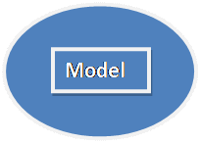

**5.4.1.2 VIEW:**

The view is a user interface. It is used to display the entire data using the model. We are using two type of view engines in view. One is the traditional view engine and another one is the Razor view engine. Traditional view engine is normal “.ASPX” page. The View component is used for all the UI logic of the application. For example, the Customer view will include all the UI components such as text boxes, dropdowns, etc. that the final user interacts with.

Razor view engine is used to develop a normal page design using HTML Helper controls. It contains “.CSHTML” extension. A syntax-wise little bit different in both view engines.

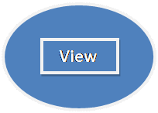

**5.4.1.3 Controller**

The controller is the heart of MVC and it handles the user request. It is a simple class. The controller can access the model and pass data to view with the help of a model. We can pass the data between the controller and view using View Data, Temp Data, and View Bag. The controller is intermediate between model and view. Controllers act as an interface between Model and View components to process all the business logic and incoming requests, manipulate data using the Model component and interact with the Views to render the final output. For example, the Customer controller will handle all the interactions and inputs from the Customer View and update the database using the Customer Model. The same controller will be used to view the Customer data.

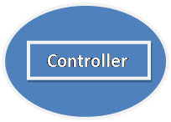

**5.4.2 MVC Framework**

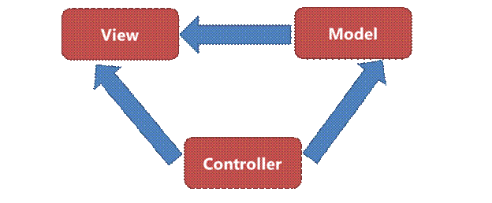

**5.4.3 Basic Work Flow of MVC**

MVC workflow starts with the user’s request. Based on the request, first, it goes the controller then goes to the corresponding action method. In the action method, we are calling all layers like business logic layer and data access layer.

Once we reach action method then it goes to the Data access layer. Sometimes while requesting, the request contains some input data that binds with the model, then goes to the data access layer.

Request reaches data access layer then goes to the corresponding database. It fetches the data from a database based on the request then goes back to the reverse format. After fetching data and binding in the model it goes to the action method.

Action method returns the result to the corresponding view with the help of model. Now, the user gets the response. Action method returns results in a different format.

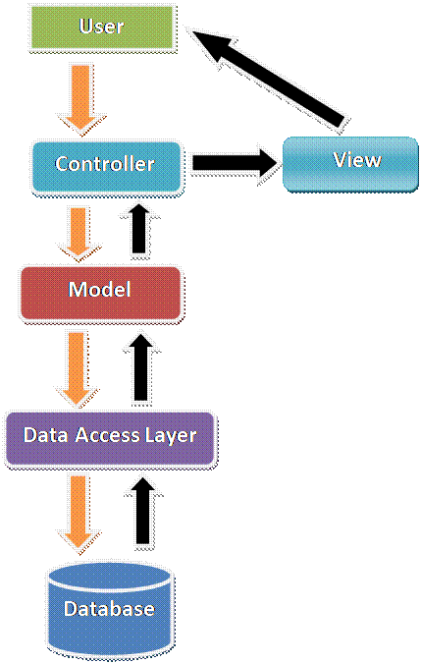

**5.4.4 HIBERNATE MVC FEATURES**

**1) Open Source and Lightweight**

Hibernate framework is open source under the LGPL license and lightweight.

**2) Fast Performance**

The performance of hibernate framework is fast because cache is internally used in hibernate framework. There are two types of cache in hibernate framework first level cache and second level cache. First level cache is enabled by default.

**3) Database Independent Query**

HQL (Hibernate Query Language) is the object-oriented version of SQL. It generates the database independent queries. So you don't need to write database specific queries. Before Hibernate, if database is changed for the project, we need to change the SQL query as well that leads to the maintenance problem.

**4) Automatic Table Creation**

Hibernate framework provides the facility to create the tables of the database automatically. So there is no need to create tables in the database manually.

**5) Simplifies Complex Join**

Fetching data from multiple tables is easy in hibernate framework.

**6) Provides Query Statistics and Database Status**

Hibernate supports Query cache and provide statistics about query and database status.

**5.4.5 ADVANTAGES OF MVC**

* Separation of Concern (SOC) is the main advantage. Here we are separating Mode, View, and Controller.
* We can easily maintain MVC application.
* Test Drive Development (TDD) is another main advantage. We can create an application with a unit
* We can write our own test case.
* Split the application and many developers can work at a time without affecting each other.
* MVC application is a default responsive web site and mobile template.
* We can create our own view engine.

**CHAPTER 6**

**SOFTWARES USED**

**6.1 SOFTWARE OVERVIEW**

Software is a set of instructions, data or [programs](https://searchsoftwarequality.techtarget.com/definition/program) used to operate [computers](https://searchwindowsserver.techtarget.com/definition/computer) and execute specific tasks. Opposite of [hardware](https://searchnetworking.techtarget.com/definition/hardware), which describes the physical aspects of a computer, software is a generic term used to refer to [applications](https://searchsoftwarequality.techtarget.com/definition/application), [scripts](https://whatis.techtarget.com/definition/script) and programs that run on a device. Software can be thought of as the variable part of a computer and hardware the invariable part.

Software is often divided into application software, or user downloaded programs that fulfill a want or need, and [system](https://searchwindowsserver.techtarget.com/definition/system) software, which includes [operating systems](https://whatis.techtarget.com/definition/operating-system-OS) and any program that supports application software. The term [middleware](https://searchmicroservices.techtarget.com/definition/middleware) is sometimes used to describe programming that mediates between application and system software or between two different kinds of application software. For example, middleware could be used to send a remote work request from an application in a computer that has one kind of operating system to an application in a computer with a different operating system.

An additional category of software is the [utility](https://whatis.techtarget.com/definition/utility), which is a small, useful program with limited capability. Some utilities come with operating systems. Like applications, utilities tend to be separately installable and capable of being used independently from the rest of the operating system.

Similarly, [applets](https://searchmicroservices.techtarget.com/definition/applet) are small applications that sometimes come with the operating system as accessories. They can also be created independently using the Dotnet or other programming languages.

A specialized type of software that allows hardware to run is [firmware](https://whatis.techtarget.com/definition/firmware). This is a type of programming that is embedded onto a special area of the hardware's [nonvolatile memory](https://searchstorage.techtarget.com/definition/nonvolatile-memory), such as a [microprocessor](https://whatis.techtarget.com/definition/microprocessor-logic-chip) or [read-only memory](https://whatis.techtarget.com/definition/read-only-memory-ROM), on a one-time or infrequent basis so that thereafter it seems to be part of the hardware.

Some of the software used for the development of this project are:

* SQL Server Management Studio
* Visual Studio

**6.2 VISUAL STUDIO**

Microsoft Visual Studio is an integrated development environment (IDE) from Microsoft. It is used to develop computer programs, as well as websites, web apps, web services and mobile apps. Visual Studio uses Microsoft software development platforms such as Windows API, Windows Forms, Windows Presentation Foundation, Windows Store and Microsoft Silverlight. It can produce both native code and managed code

Visual Studio includes a code editor supporting IntelliSense (the code completion component) as well as code refactoring. The integrated debugger works both as a source-level debugger and a machine-level debugger. Other built-in tools include a code profiler, forms designer for building GUI applications, web designer, class designer, and database schema designer. It accepts plug-ins that enhance the functionality at almost every level—including adding support for source control systems (like Subversion and Git) and adding new toolsets like editors and visual designers for domain-specific languages or toolsets for other aspects of the software development lifecycle (like the Team Foundation Server client: Team Explorer).

Visual Studio supports 36 different programming languages and allows the code editor and debugger to support (to varying degrees) nearly any programming language, provided a language-specific service exists. Built-in languages include C, C++, C++/CLI, Visual Basic .NET, C#, F#, JavaScript, Typescript, XML, XSLT, HTML, and CSS. Support for other languages such as Python, Ruby, Node.js, and M among others is available via plug-ins. Java (and J#) were supported in the past.

**6.2.1 ASP.NET**

ASP.NET is an open-source server-side web application framework designed for web development to produce dynamic web pages. It was developed by Microsoft to allow programmers to build dynamic web sites, web applications and web services.

It was first released in January 2002 with version 1.0 of the .NET Framework, and is the successor to Microsoft's Active Server Pages (ASP) technology. ASP.NET is built on the Common Language Runtime (CLR), allowing programmers to write ASP.NET code using any supported .NET language. The ASP.NET SOAP extension framework allows ASP.NET components to process SOAP messages.

ASP.NET's successor is ASP.NET Core. It is a re-implementation of ASP.NET as a modular web framework, together with other frameworks like Entity Framework. The new framework uses the new open-source .NET Compiler Platform (codename "Roslyn") and is cross platform. ASP.NET MVC, ASP.NET Web API, and ASP.NET Web Pages (a platform using only Razor pages) have merged into a unified MVC.

**6.2.1.1 3 TIER ARCHITECTURE**

A 3-tier architecture is a type of software architecture which is composed of three “tiers” or “layers” of logical computing. They are often used in applications as a specific type of client-server system. 3-tier architectures provide many benefits for production and development environments by modularizing the user interface, business logic, and data storage layers. Doing so gives greater flexibility to development teams by allowing them to update a specific part of an application independently of the other parts. This added flexibility can improve overall time-to-market and decrease development cycle times by giving development teams the ability to replace or upgrade independent tiers without affecting the other parts of the system.

For example, the user interface of a web application could be redeveloped or modernized without affecting the underlying functional business and data access logic underneath. This architectural system is often ideal for embedding and integrating 3rd party software into an existing application. This integration flexibility also makes it ideal for embedding analytics software into pre-existing applications and is often used by embedded analytics vendors for this reason. 3-tier architectures are often used in cloud or on-premises based applications as well as in software-as-a-service (SaaS) applications.

**6.2.2 ADO.NET**

ADO.NET is a data access technology from the Microsoft .NET Framework that provides communication between relational and non-relational systems through a common set of components. ADO.NET is a set of computer software components that programmers can use to access data and data services from a database. It is a part of the base class library that is included with the Microsoft .NET Framework. It is commonly used by programmers to access and modify data stored in relational database systems, though it can also access data in non-relational data sources. ADO.NET is sometimes considered an evolution of ActiveX Data Objects (ADO) technology, but was changed so extensively that it can be considered an entirely new product.

**6.3 MICROSOFT SQL SERVER MANAGEMENT STUDIO(SSMS)**

Microsoft SQL Server Management Studio (SSMS) is an integrated environment to manage a SQL Server infrastructure. It provides a user interface and a group of tools with rich script editors that interact with SQL Server.

**6.3.1 SSMS Tools**

SSMS provides tools to configure, manage and administer instances of [Microsoft SQL Server](https://searchsqlserver.techtarget.com/definition/SQL-Server), and it brings together a range of graphical and visual design tools and rich script editors to simplify working with SQL Server. SSMS combined features come from Enterprise Manager, Query Analyzer and Analysis Manager, along with features included in previous releases of SQL Server. It supports most of SQL Server's administrative tasks and maintains a single, integrated environment for SQL Server Database Engine management and authoring.

**6.3.2 SSMS Components**

Microsoft SQL Server Management Studio features include Object Explorer, which can view and manage all objects in a SQL Server instance; Template Explorer, which builds and manages files of text that can be reused to speed up query and script development; Solution Explorer, which builds the projects used to manage administration items, such as queries and scripts. (Microsoft plans to remove Solutions Explorer in versions beyond [Microsoft SQL Server 2016](https://searchsqlserver.techtarget.com/definition/Microsoft-SQL-Server-2016)). SSMS components customize [keyboard shortcuts](https://whatis.techtarget.com/definition/keyboard-shortcut) and viewing property pages; connect to instances of the Database Engine and Analysis Services; visual design tools; and interactively build and [debug](https://searchsoftwarequality.techtarget.com/definition/debugging) queries and scripts.

**CHAPTER 7**

**OUTPUTS**

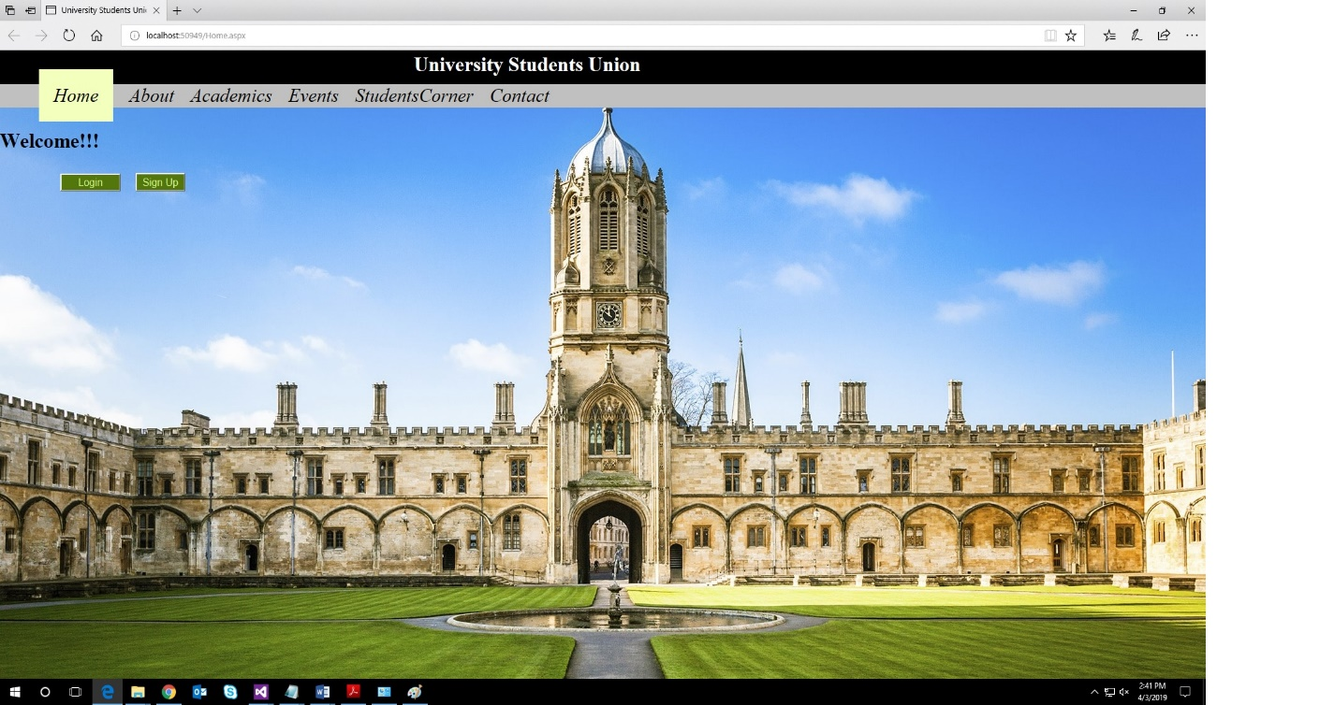

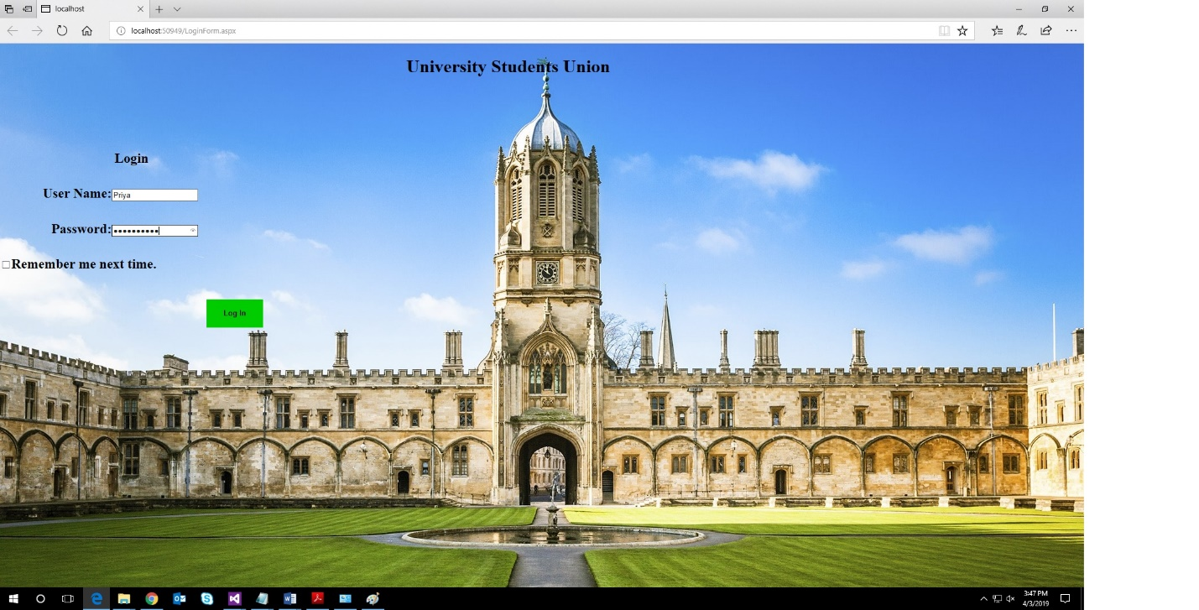

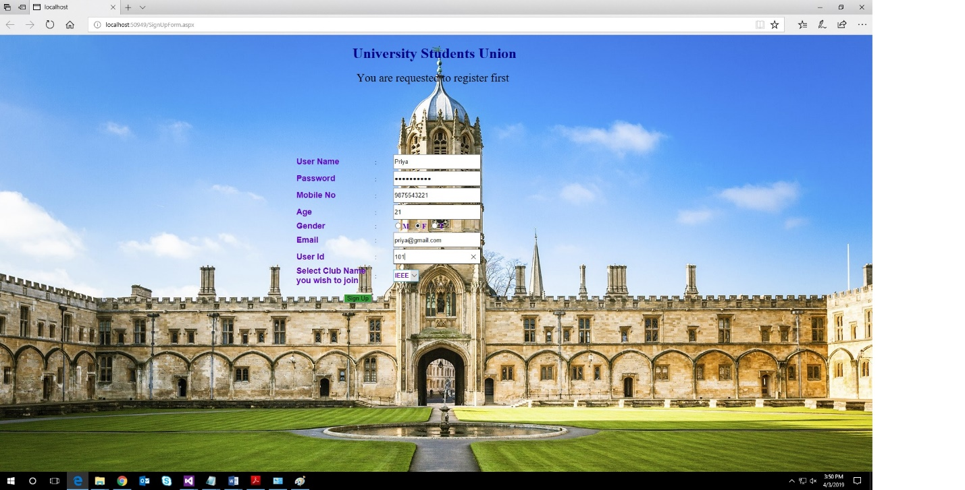

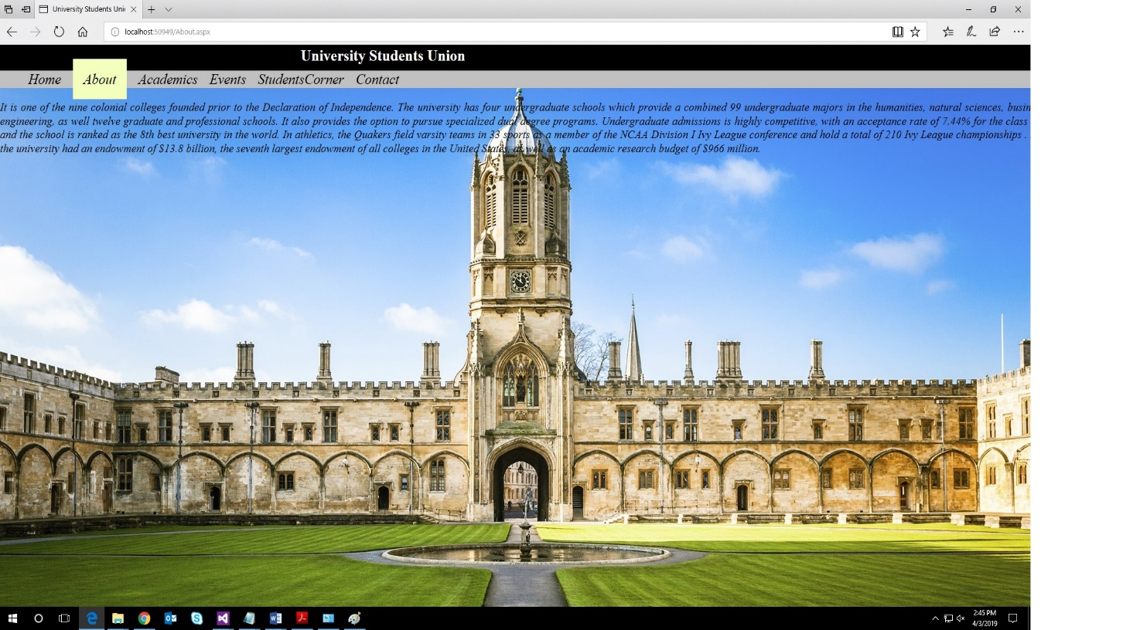

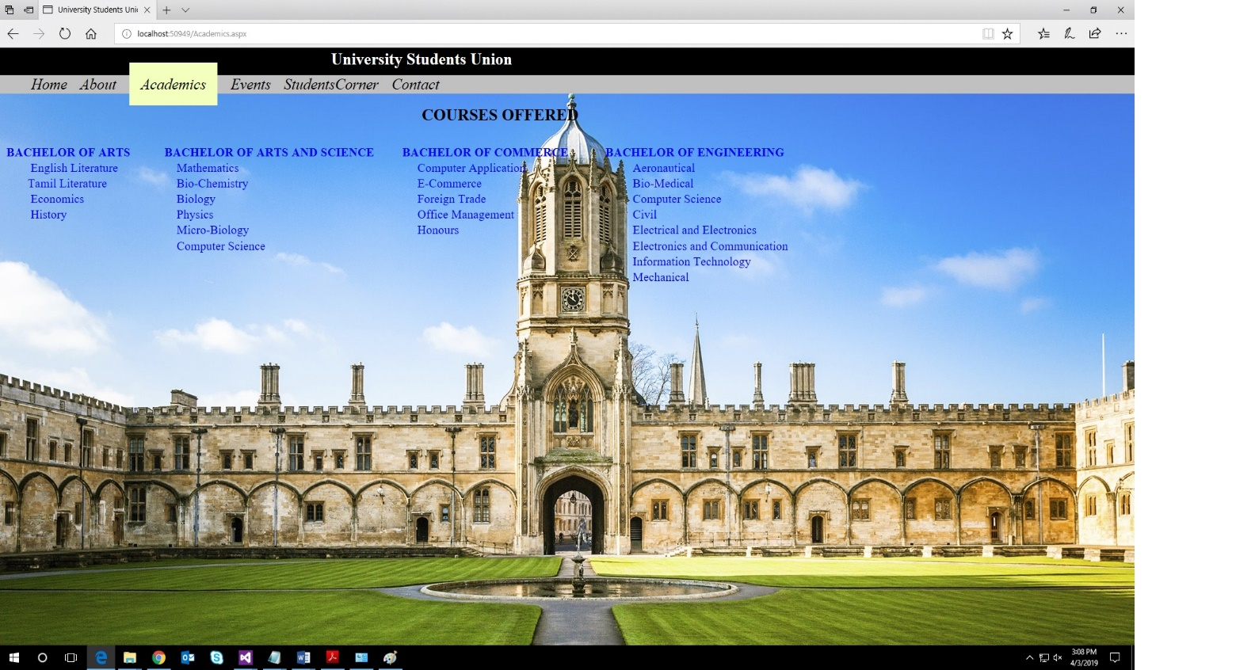

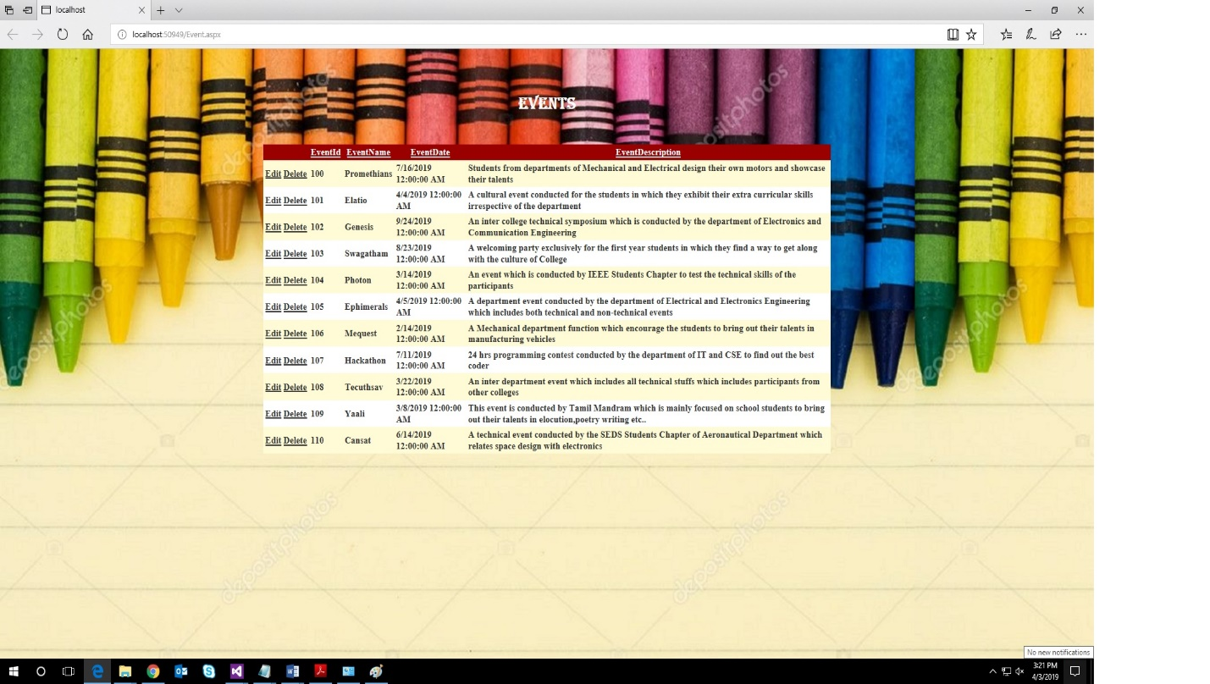

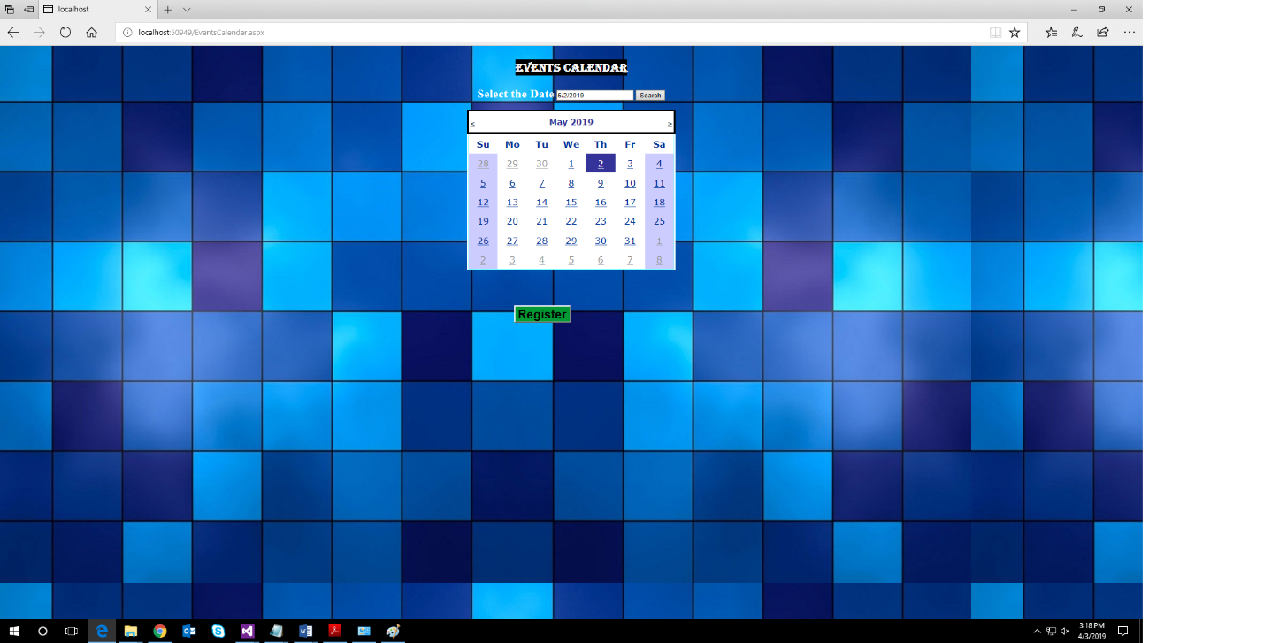

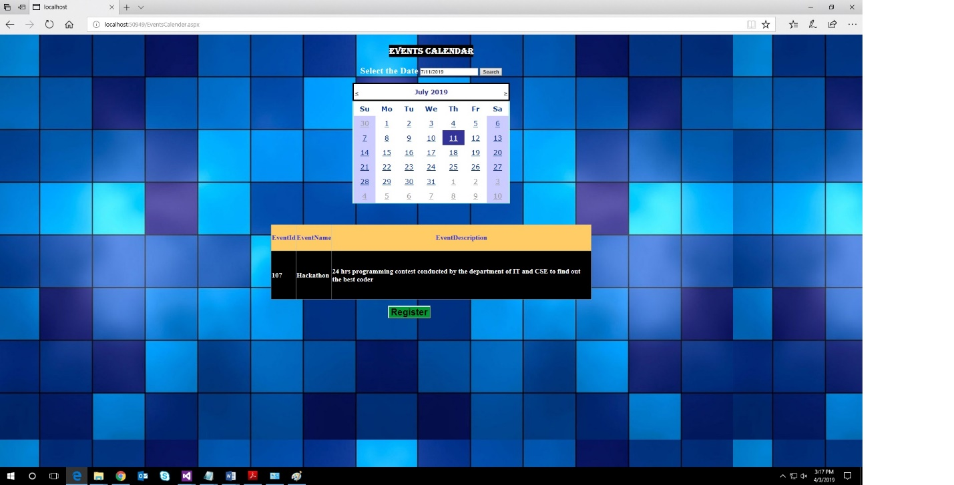

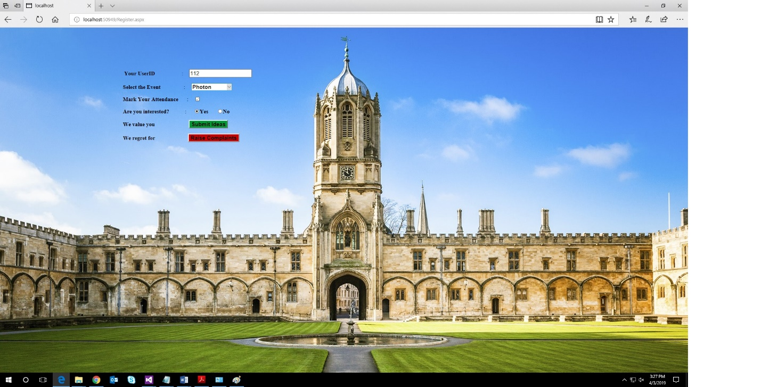

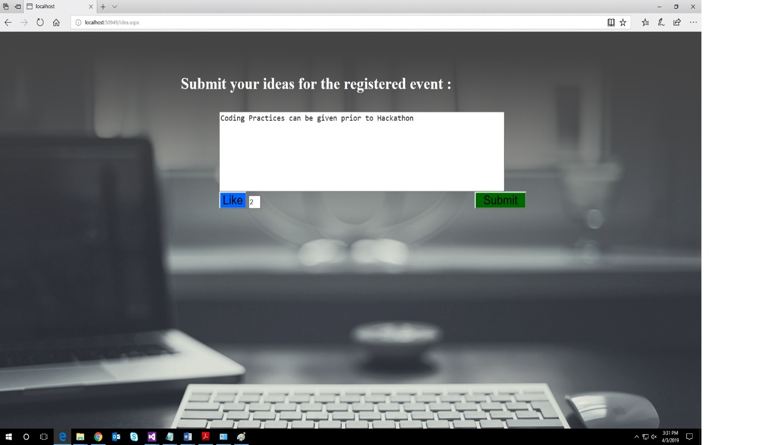

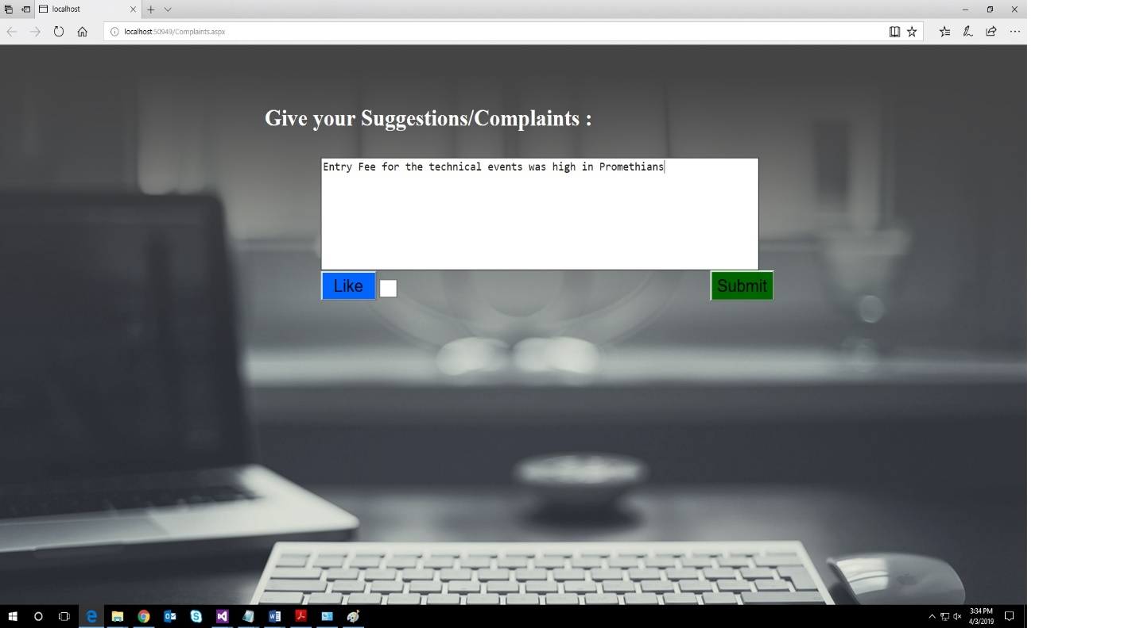

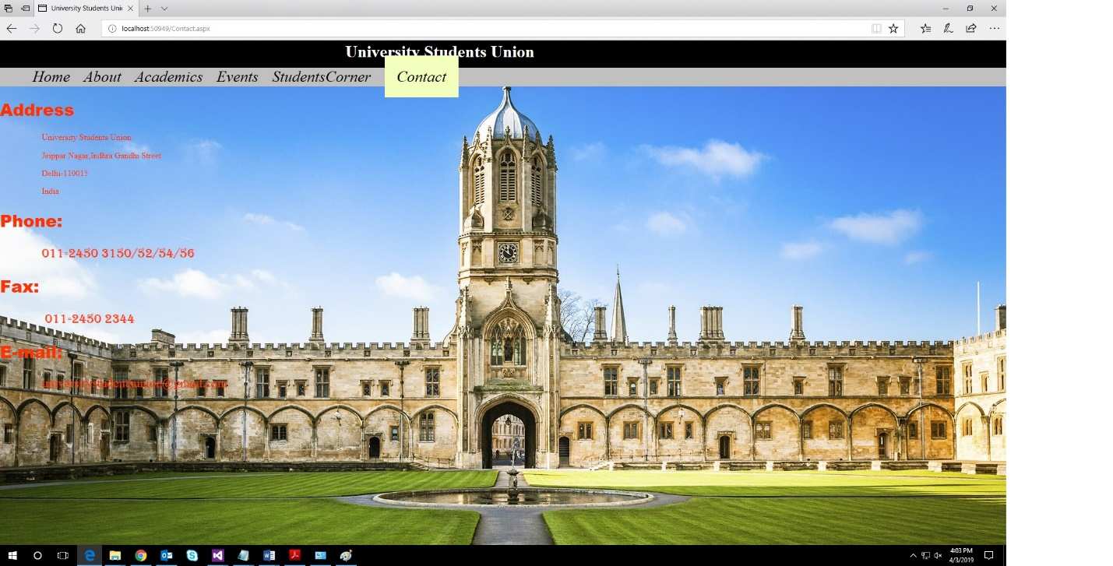

**CHAPTER 8**

**CONCLUSION**

Thus the design of University Website helps the students to know the upcoming events and register themselves accordingly. This also makes the website more interactive to the students by asking them to share their ideas and provide suggestions.